**Unit 11 : Inverse Functions**

11-1 Inverse Functions Revisited

Rational Function: Graph and show it’s one-to one. Then find inverse graphically and algebraically.

1151 quadratic. Restrict domain. Which of +/- to pick via dom/range argument.

Table problems like in 1151.

What must be true about a continuous one-to-one function?

FM 4.4

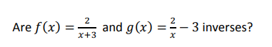

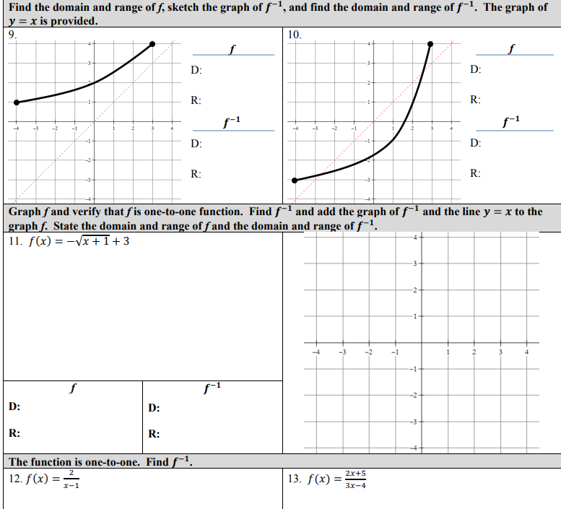



**S-Z 5.2:**

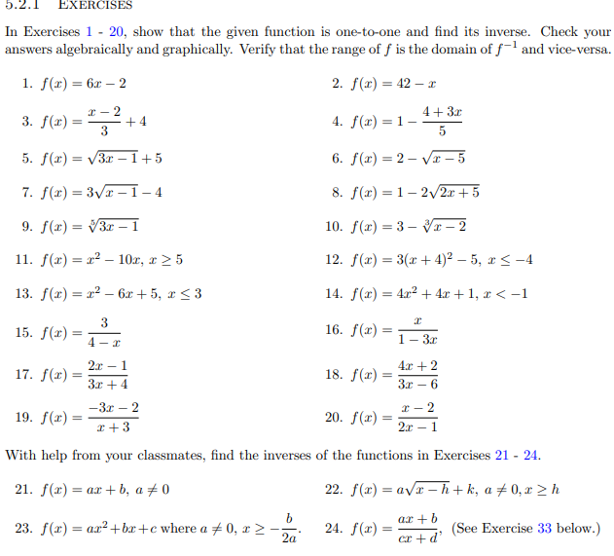

**Active Reading: 7.2:**

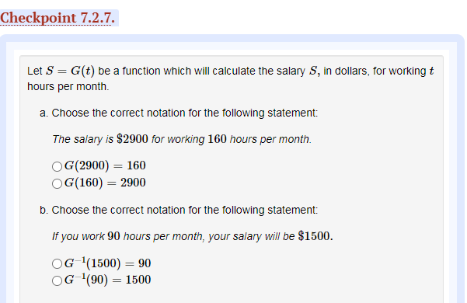

APC 1.7:

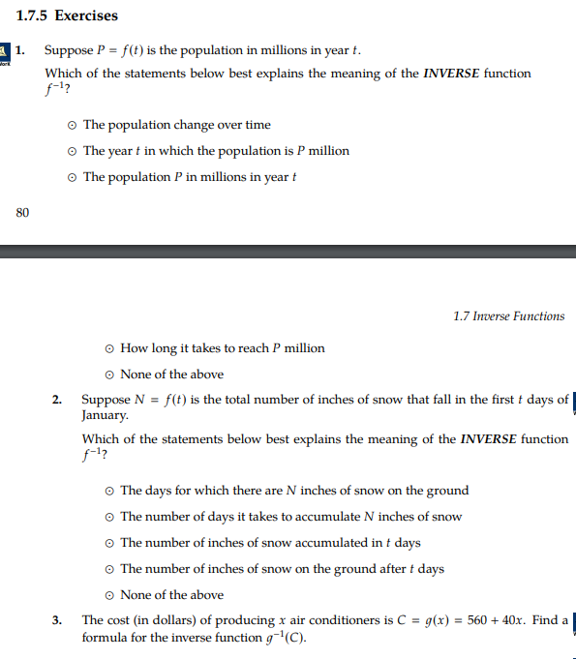

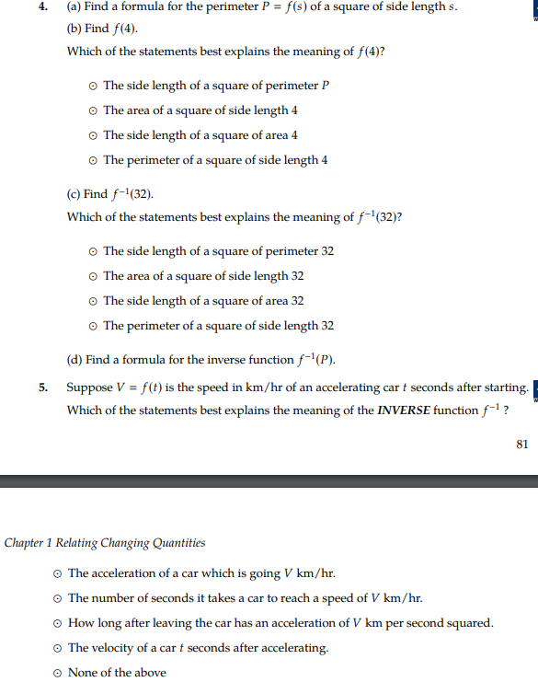

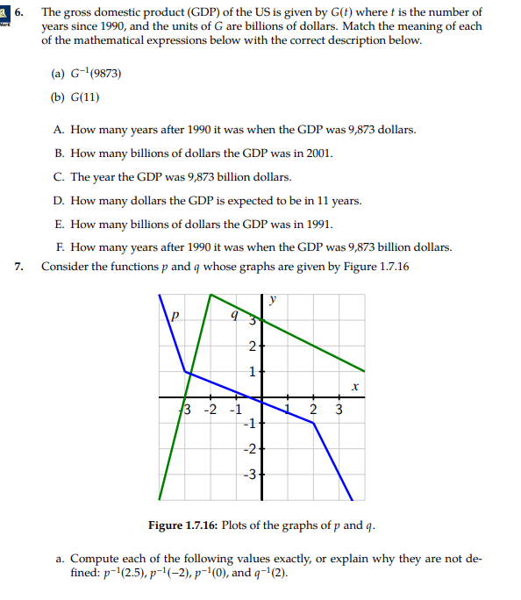

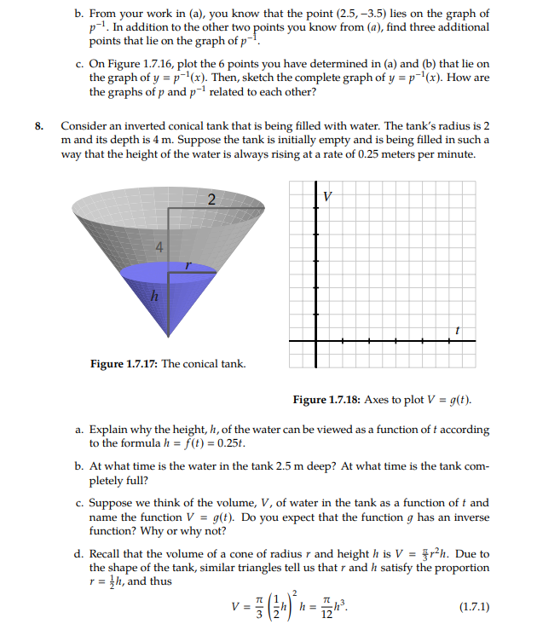

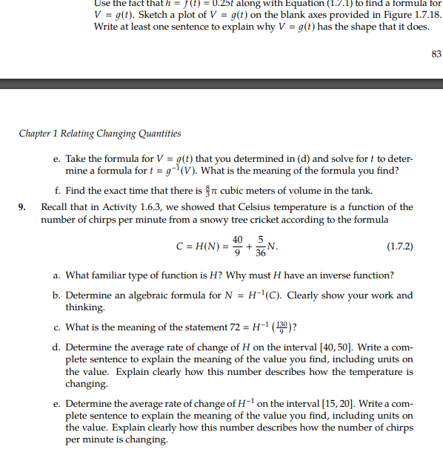

**Calc-Medic**

1. The adult weight of your dog is determined by the number of calories you feed your puppy. The function $w={\left(\frac{k}{130}\right)}^{\frac{4}{3}}$ relates the number of kilocalories per day, *k*, to the adult weight of the dog (in kilograms), *w*.
   1. If you feed your puppy 800 kcal a day, what can you predict will be their adult weight?
   2. Complete the table to predict the adult weight of your pet with each of the different diet plans. Round to the nearest tenth.

|  |  |  |  |
| --- | --- | --- | --- |
| $k$ (kcal a day) | 600 | 800 | 1000 |
| $w$ (weight in kg) |  |  |  |

* 1. If you want your dog to weigh 15.2 kg, how many calories should you feed him a day?

1. The ideal adult weight for a golden retriever is about 30 kg. How many calories a day should you feed a golden retriever to achieve this ideal weight? Show how you got your answer.

|  |  |  |  |  |
| --- | --- | --- | --- | --- |
|  | 9 | -2 | 7 | 12 |

1. A picture containing group, couple, public, large

   Description automatically generatedThe graph of $h\left(x\right)$ is shown below. Find $h^{-1}\left(2\right).$
2. To convert from degrees Fahrenheit to degrees Celsius, we can use the equation

$C=\frac{5}{9}(F-32)$. Write the inverse of this function and what it represents.

1. The function $f(x)$ gives the distance in miles that an ambulance can travel within *x* minutes of receiving an emergency phone call. Interpret the meaning of $f^{-1}\left(26\right)=20$ in context.
2. Let $g\left(x\right)=\frac{1}{x+2}$.
   1. Find $g^{-1}$.
   2. Use compositions to verify that $g$ and $g^{-1}$ are in fact inverses.
3. Sketch a rough graph of this hiker’s elevation over time.

|  |  |
| --- | --- |
| Time  (hours) | Elevation  (above sea level) |
| 0 | 11,629 feet |
| 1 | 11,900 feet |
| 2.5 | 13,060 feet |
| 4 | 14,066 feet |
| 5 | 12,619 feet |
| 5.5 | 11, 629 feet |

1. Can the hiker’s elevation be considered a function? Why or why not?
2. Explain why each elevation (except the summit) is reached at least twice on the hiker’s journey.
3. Suppose that we wanted to find the *inverse*: to figure out the time at which the hiker reached a certain elevation.
   1. Identify the input and output of this inverse relation.
   2. Explain what this tells you about whether or not $H^{-1}$ is a function.
4. Sketch the graph of $f(x)={\left(x-3\right)}^{2}$. Is the inverse of $f$ a function? Support your answer with information from the graph. If not, how could you restrict the domain of $f$ so that the inverse *is* a function?

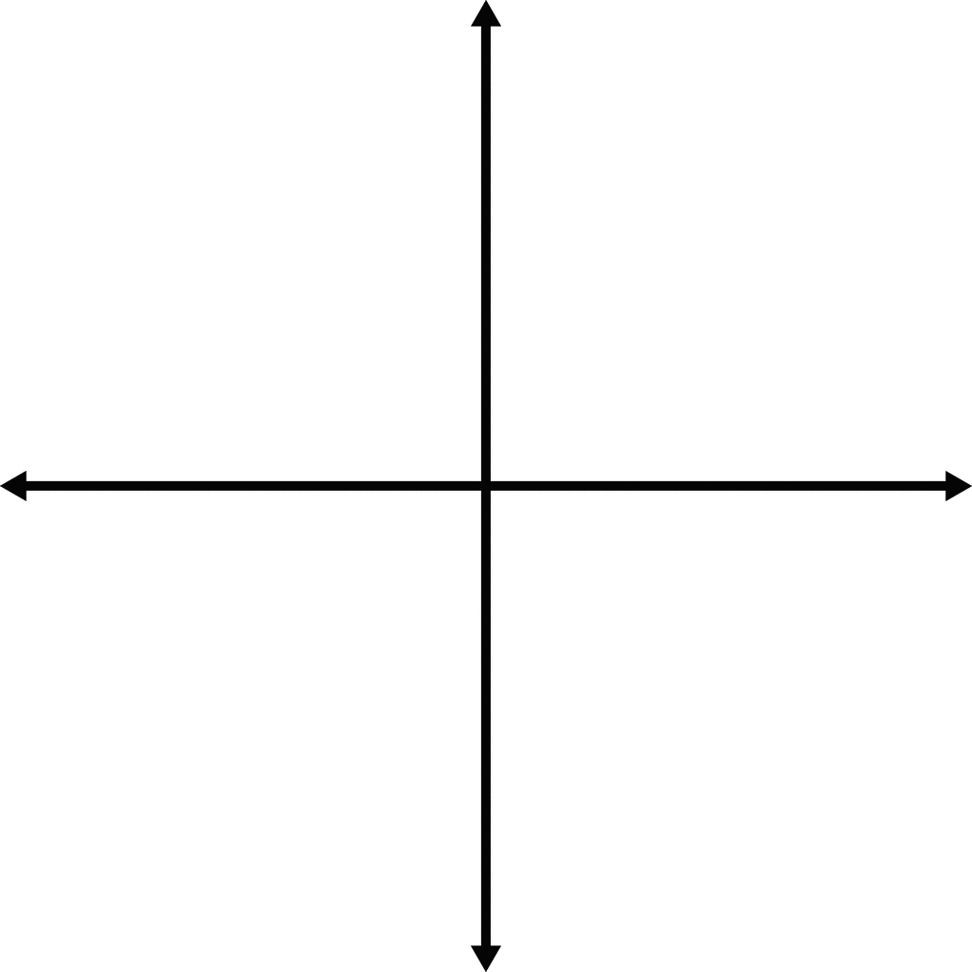

1. Find the inverse of $y=\sqrt{x-4}$ and state its domain and range.

**MFG 5.1:**

